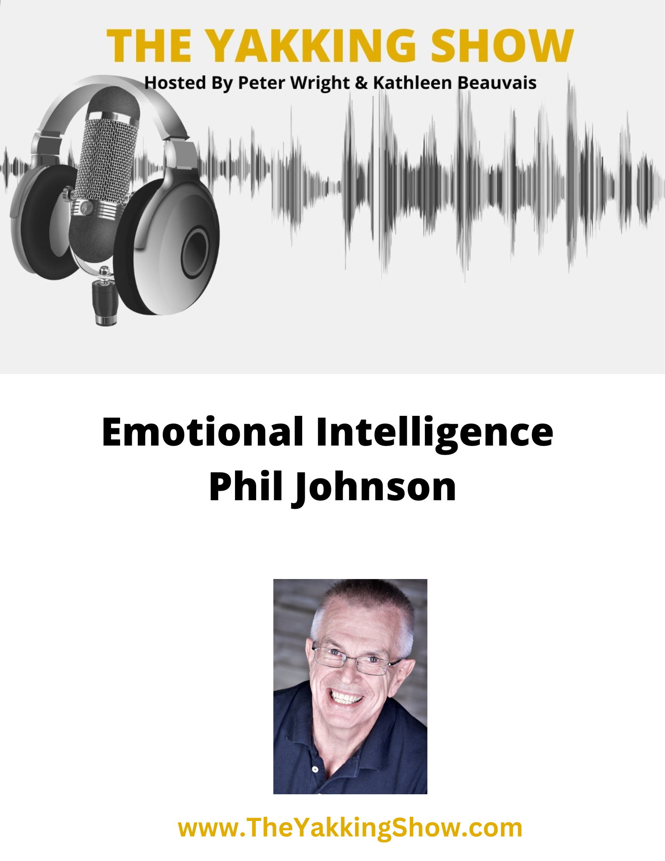

We are pleased to present the transcript of our discussion with Phil Johnson an expert on Emotional Intelligence and the founder of The Master of Business Leadership Executive Program.

Suffering And The End Of Suffering

The desire for better results is the beginning of awakening and the end of suffering. This is where all Master of Business Leadership program members begin their journeys. You begin to realize the voice in your head is not who you are.

Your state of consciousness in the present moment determines how you experience your life. It determines your actions and how you will respond to situations. It determines what happens next. The challenges you face may, from time to time, trigger you to slip back into unconsciousness.

The development and enhancement of your emotional intelligence will enable you to turn those challenges into opportunities for better results and end the suffering. Your presence can help to reduce the need for suffering in others.

The Freedom From Fear

One of the many benefits that comes from the development of emotional intelligence is that it enables us to separate ourselves from our ego based fears. This allows us to feel and move through our fears rather than being controlled by them. It creates the space between stimulus and response, between what happens and how we choose to respond, that allows us to make better choices.

Others benefits that result from the emotional labor this requires are inspirational leadership and higher consciousness or awareness that leads to remarkable results. The mindful, ongoing practice of emotional intelligence builds trust and higher levels of engagement. The combined benefits of this type of experiential intelligence enables us to turn the challenges we face in an ever changing world into opportunities for better career, personal and corporate results.

Regards, Phil

Phil Johnson, Founder
Master of Business Leadership Executive Program

 https://calendly.com/mblcoach/chat-with-phil
LinkedIn https://www.linkedin.com/in/philipjpjohnson/
YouTube https://www.youtube.com/user/PhilJohnsonMBL


Phil Johnson - Emotional Intelligence
peter: It's Peter Wright and Kathleen Beauvais in Ontario, Canada with another exclusive episode for our premium members of the Yakking Show. First, let me introduce co-host Kathleen Beauvais from Waterloo, Ontario. Hi, Kathleen. How are you doing today?
kathleen: I'm doing great. Peter. Thank you for that introduction. We always have interesting guests who are experts in their fields for our premium members.
And today is no exception. We want to welcome back Phil Johnson, who was with us in August to talk to us about his Master of Business Leadership program, which for the past 21 years has been helping executives and organizations bet on themselves by developing their emotional intelligence. Today, Phil will be presenting a slide show to help us get a better understanding of the importance of emotional intelligence and how this can help your business.
Phil, welcome to the show. How are you?
phil: I'm great, Kathleen. Peter. Thank you. It's great to be back with you. I'm looking forward to our discussion.
kathleen: So are we, I can tell you now. For the benefit of those who haven't had the opportunity to see your previous video and I urge everybody to do that.
Can you give us a little bit of information about yourself and what led you to embark on this career path? Before we dig into this very fascinating topic.
phil: Yeah. For the past 21 years, as you say, I've been an executive coach working with executives and organizations all over the world to help them to achieve much better results by developing their emotional intelligence.
With the program I've created called the Master of Business Leadership program. I've been on this journey for 54 years. And I'm 68 now. So I started quite early. And along the way, I spent 20 years in the semiconductor industry as an executive travelling about 60,000 miles a year throughout North America and in the Pacific rim.
kathleen: Goodness.
phil: But I was born with dyslexia and I started working when I was nine years old, pulling copper wire out the back of factory dumpsters and selling it for 5 cents. Really so it's been quite a journey and I'd be happy to share the lengthier version of that if anybody's interested.
But yes the work I have been doing for the last 21 years comes full circle with a promise I made to myself 54 years ago. And it's created remarkable results for individuals and organizations all over the world.
kathleen: Mm, wonderful. Well, without further ado, Phil, please go ahead and do a screen share and let's, let's get with it.
phil: So this presentation, as I said, is an introduction to a much deeper discussion about emotional intelligence. What I've been proving over the last 21 years all over the world is that the development of our emotional intelligence is a critical part of our development. That guarantees career, personal and corporate success in individuals that have gone through the MBL program. The results of that have led to the development of their inspirational leadership, their emotional intelligence, greater awareness of what's going on in them and around them and remarkable results.
kathleen: So, can we just for the benefit of some people who haven't, again, listened to the previous video, can you give us just a description or a definition of emotional intelligence and how is that different from intellectual intelligence?
phil: It's very different. The development of the emotional intelligence occurs as we move out of our comfort zone and through the fear and anxiety that that triggers in us. So that's what I call emotional labour. And that's very different from intellectual intelligence.
Intellectual intelligence is, genetic. If you have a high IQ, your parents had a high IQ, their parents had a high IQ and and you inherited that. So not everybody can have a 160 IQ but anybody, everybody can develop their emotional intelligence and the ROI, the effectiveness of developing emotional intelligence is far greater than our intellectual intelligence.
As a matter of fact, UC Berkeley and California completed a four-year study comparing IQ and EQ, and they determined that emotional intelligence was 400% more valuable in determining success than intellectual intelligence. And I think that's actually low in my opinion, from my observations.
But even if we go with the results of that study, it really points to why the development of our emotional intelligence is so valuable, so important.
peter: good. Well, that's significant even 400% big difference.
kathleen: And would you say that emotional intelligence is really an indication of how a person would react to a situation?
phil: Yes. Okay. And it's how we react to change. We have a 500 billion year old brain that doesn't react well to change. There's significant both biological and sociological resistance to change. And that's really important, especially actually in this century because we're facing, a tsunami of change.
Change is increasing at an exponential rate. Some scientists have estimated that in this century we could experience the equivalent of 20,000 years worth of change. Wow. And that in this decade alone, we're going to experience the equivalent of 100 years’ worth of change. So change is increasing exponentially.
Never happened before. And we have a 500 million-year-old brain that really resists change. So the tsunami of change we're facing is going to create increasing levels of drama, chaos, and conflict. And we really need to be developing our emotional intelligence so that we're able to move through the fear and anxiety that changing innovation creates in us.
Let me give you an example. There's a part of our old lizard brain called the amygdala that has been trying to keep us safe and alive by making sure we never leave the safety of our comfort zone. And if we do it creates a hormone in our bloodstream called cortisol. And that causes the executive center of our brain, our pre cortex to shut off.
And we go into what psychologists referred to as an amygdala hijack, we go into fight flight or freeze mode. Some people lash out. Some people run away or some people freeze like a deer in the headlights. And when that happens in conflict situations, sometimes people die and when it happens in business or personal situations, relationships die, we burn trust.
So as an analogy, if you think of your amygdala as a very frightened four-year-old child, the development of our emotional intelligence acts like a big brother or a big sister to quiet the amygdala response down and better enable us to feel the fear and anxiety that changing innovation creates in us and move through it towards what it is we're trying to achieve, as opposed to allowing that anxiety, to keep us trapped in our comfort zone.
Right. Does that make sense?
peter: Yeah. Makes a lot of sense. Absolutely.
phil: Makes sense. So the development of our emotional intelligence, more and more companies are developing, hiring and promoting emotional intelligence. As a matter of fact, there's one company that's currently doing over a trillion dollars a year in revenue.
That's a thousand billion dollars a year in revenue. Whose primary hiring focus is on the search for people with above-average levels of emotional intelligence. And if you're interested, I'll, I'll tell you what that is at some. I'll tell you who that is at some point mm-hmm, absolutely interesting.
peter: Yeah. That's a bit of a teaser for our audience
kathleen: Absolutely, for sure.
peter: I wonder if some of them can guess already, if not, they'll have to wait.
phil: Oh, there's only, there's only a couple of companies that are, that are doing a trillion dollars a year in revenue. That's right. Not many
phil: So here's a little fun game I play with new MBL clients. Okay. And it's part of a, an initial kind of discussion. Yeah. So here's a picture with nine dots, and I ask people if they can think of a way to connect all of those nine dots without taking their pen off the paper and I give them time to do that.
Can you think of a way to connect those nine dots with four straight lines,

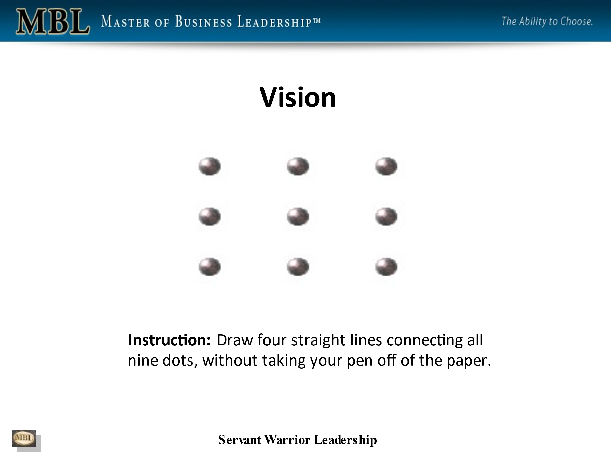
peter: I'm going to keep quiet, because I've seen this before many years ago. And then reading your information I was reminded, so I'm not going to spoil it.
kathleen: Well, and I had the opportunity to see this before, but what was, what was interesting is that, and I don't know if most people would think this way, but in your initial reaction, when you say connect the dots without taking your pen off the paper, you're literally trying to connect the dots.
But in this case, you kind of have to go outside, outside the, outside the like go through them in order to make them connect. You're
peter: trying to say outside the box, sketching, outside
kathleen: thinking outside the box. Correct. But most people, I think, or many people would probably not do that. Right. Their initial reaction is to try and connect them literally without going outside the box.

phil: So for our listeners, here's what that would look like.
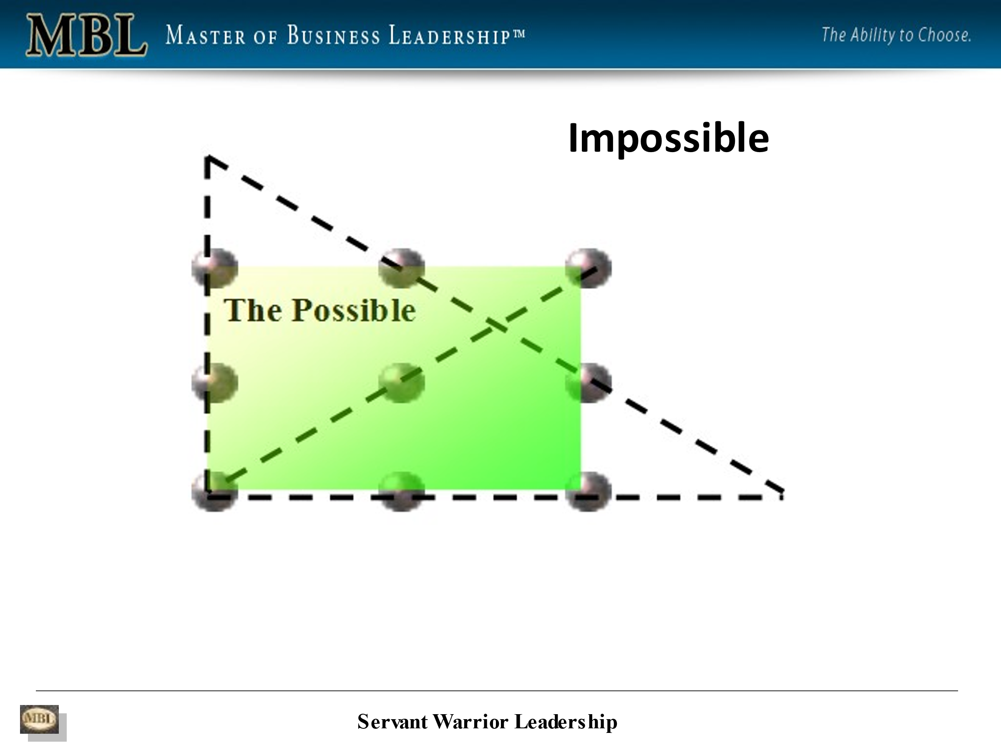
And it is possible. So here's what it would look like. 1, 2, 3, 4. Oh, yep. But the bigger discussion here and the reason why most people find this difficult is that. They immediately draw a box around the periphery of the nine dots, right. And what's inside the box is what they view as possible. And what's outside the box is what they view as impossible, impossible.
And this is what we all do. It's called our paradigm. It's called our belief system and our belief system or our paradigm determines what's possible or impossible for us. Okay. It determines what we see and what we don't see.
peter: I've got to ask you, where does that paradigm come from?
phil: It comes from our habits, the life experience we've had everything we've been exposed to has created a belief system of what's possible or impossible for us. So that becomes limiting and self-reinforcing.

peter: So that is, is a combination of parental and familial influence and what we've learned from the society we've grown up in, all those factors and our own personal makeup, I guess, education, all those factors combined to create that paradigm, everything.
So would I be correct in saying that if we took someone with a totally different experience, background family culture and presented a similar problem to them, they would perhaps look at it in a completely different way?
phil: They absolutely would. As a matter of fact, everybody looks at it from their own paradigm. Every single person on the planet is viewing the world through their belief system, through their paradigm. So it becomes, think of your paradigm as the glasses, as that tint what you're saying, that determine the stories you tell yourself about what's possible or impossible for you.
It creates the limiting beliefs that our amygdala reinforces to make sure we never leave that paradigm. Right. We never leave our comfort zone. We never leave the safety of our cave so that our level of consciousness is a reflection of our belief system. Our paradigm. And we cannot get better results than our current level of consciousness.
In order for us to get better results than we're currently getting, we need to raise our level of consciousness. And this is part of what occurs in the MBL program, in the Master of Business Leadership program. You become more conscious of what's going on in you and around you, you are able to move outside of your comfort zone outside of your paradigm about what's actually occurring.
Right?
So we don't see things. Here's a phrase lots of MBL clients like. We don't see things as they are, we see them as we are. Our reality and the reality often are not the same thing, because our reality is being filtered through our belief system, through our paradigm.
Does that make sense?
peter: Yeah, absolutely.
kathleen: Yeah.

phil: Here's an example. What do you see in this picture? And this is really for our listeners, but what do you see in this picture?
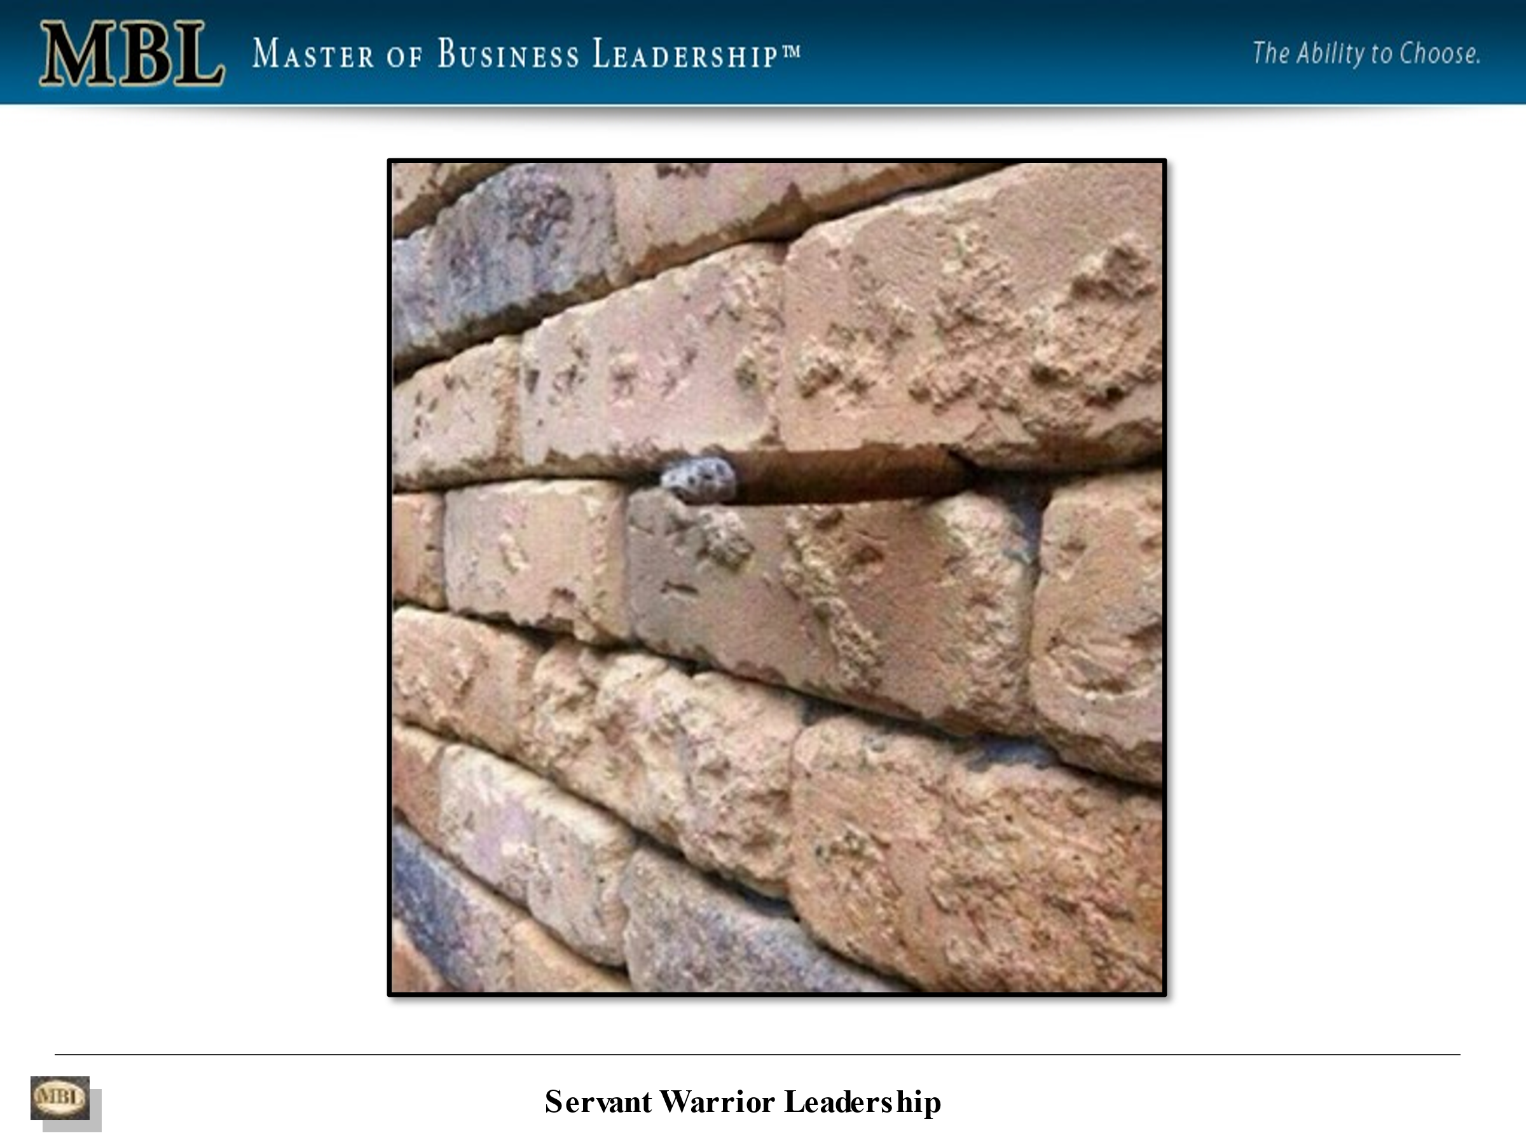
kathleen: Well, we're seeing,
For those of you just listening, we're seeing a brick wall and what looks to be a stone between bricks caught between bricks.
phil: Yeah. Great. What if I told you that there was a six-inch cigar sticking out of that wall?
kathleen: Oh for heaven's sakes.
phil: So here it is.
kathleen: Oh, yes, I see it now.

phil: so this is very important because it's part of our brain called a reticular activation system that sees everything. But what we see in our unconscious mind is only a fraction of what our conscious mind sees.
Our unconscious mind sees everything, but what we see consciously is a reflection of our paradigm of the walls we have created around what's possible or impossible for us. Does that make sense?
peter: Yes, it makes a lot of sense.
phil: Here's another example. We've all seen the FedEx logo.
I'm going to just take that away for a second. Were you able to see. The arrow in the FedEx logo.
peter: I never had before seeing your literature. I had never noticed.
kathleen: I had never noticed it until you had pointed it out in our previous in our interview with you.
phil: So here's here it is. It's between the E and the X.
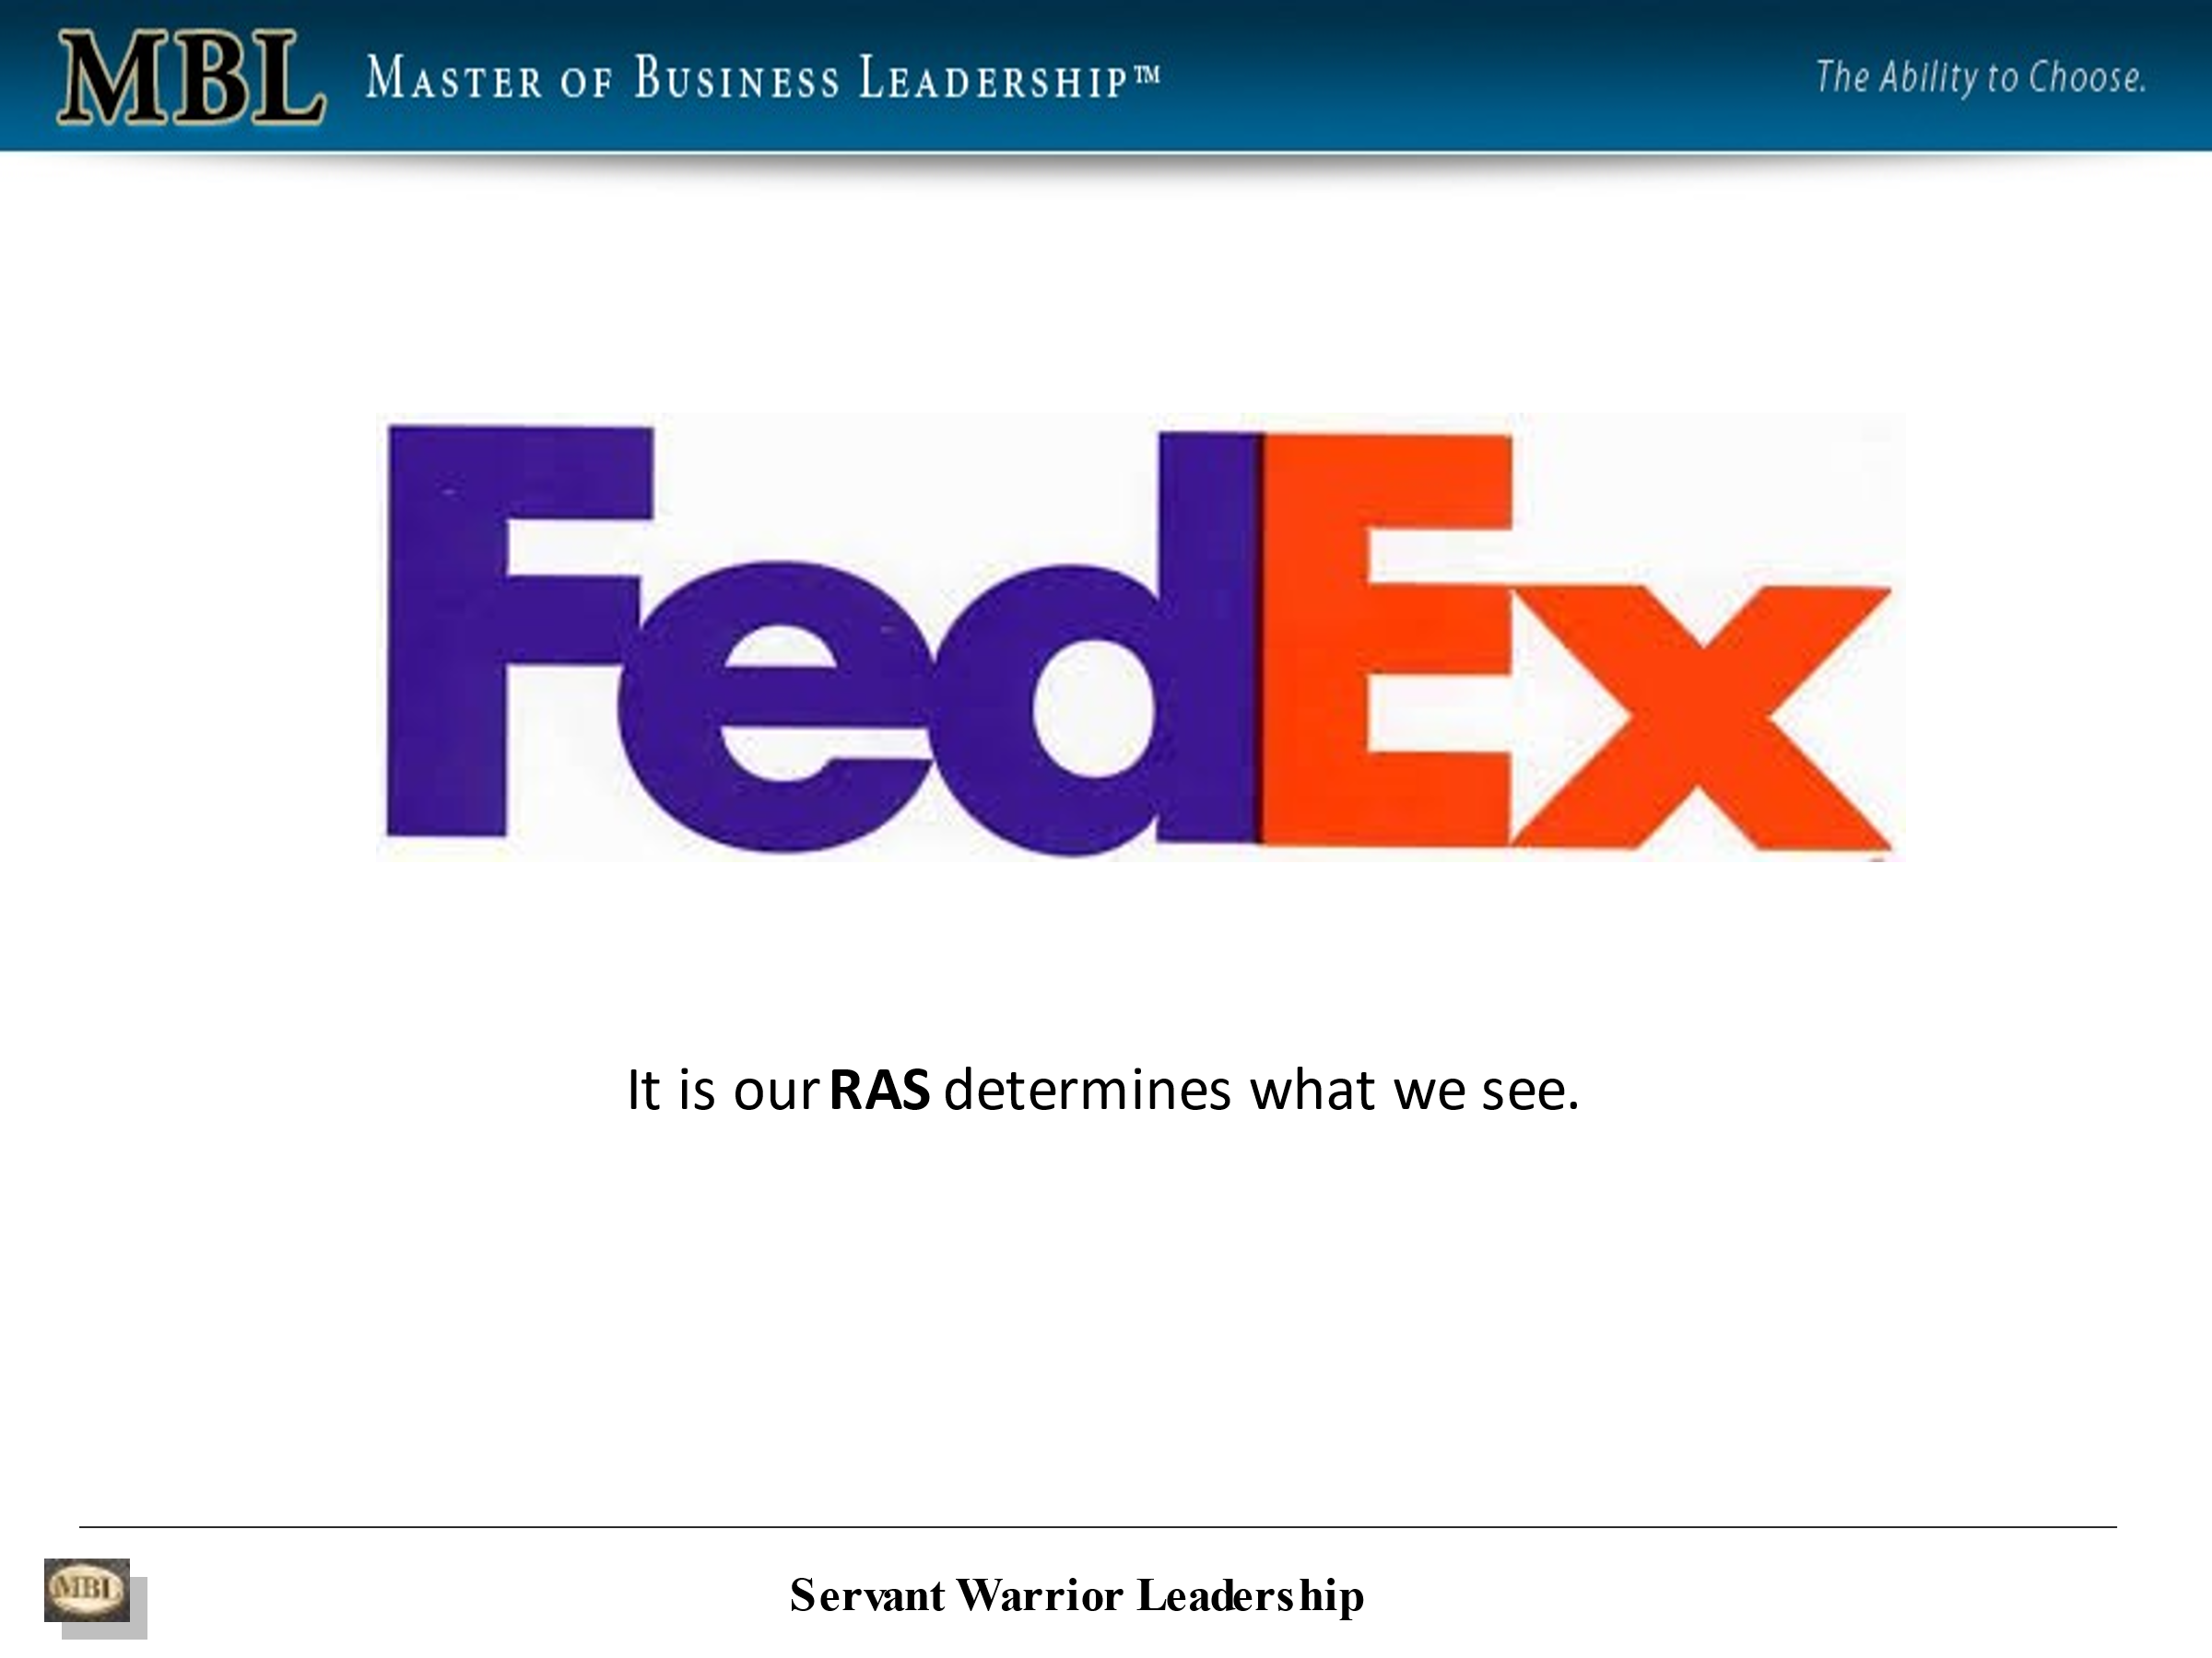
And so FedEx did that purposely because they wanted to communicate with our unconscious mind where purchasing decisions are made, purchasing decisions are made emotionally and our unconscious mind. And then after we've made the decision, we look for features and benefits consciously to justify the decision we've already made unconsciously.
Right. So they wanted the people that when they saw this logo, that it would reinforce that FedEx is all about moving things from A to B. Yep. They wanted to imprint that into the reticular activation system in our mind. So as we learn to lower our walls, as we go through the MBL program, part of what occurs is we expand our consciousness, we expand our awareness about what's going on in us and around us, and that enables us to achieve far greater results.
So there's another thing I want to mention just as kind of an introduction is that we're only conscious about three to five % of the time. The rest of the time, we're relying on our unconscious habits to determine our behavior and our results.
kathleen: Really three to five %.

phil: Oh, if you think about it so anything you practice long enough, like learning to tie your shoes moves from being a conscious activity to an unconscious habit.
And that process scientists, brain scientists refer to it's called automaticity it's whatever we practice long enough moves from a conscious activity to an unconscious habit. It's like driving a car. When you first learned how to drive a car it was overwhelming, seemingly overwhelming.
And now you get in and you start the car and you pay much less attention to the automatic process of driving than you used to. That's because your brain has moved it from a conscious activity to more of an unconscious activity. So if we want better results than we're currently getting, we have to develop better habits. We cannot get better results than we're currently getting with our existing habits.
If we want better results, we need to develop better habits. And we can do that at any age. It's called brain plasticity or neurogenesis. So a habit contains three components, a trigger, an action and a reward. So the habits that we've developed in our life. That are responsible for 95, 98% of our results every day.
We put in place because they got us something we wanted, they got us a reward that we wanted. So we kept doing it and in doing it, we strengthen those habits. But what worked for us at one point in our life might end up killing us. What stands in the way of new habits to get better results?
Let me give you an example. You're right. There's actually a group of scientists that were paid a few million dollars to go into the Arizona desert many years ago and study the Sand wasp.

And here's an example of what a Sand wasp looks like.
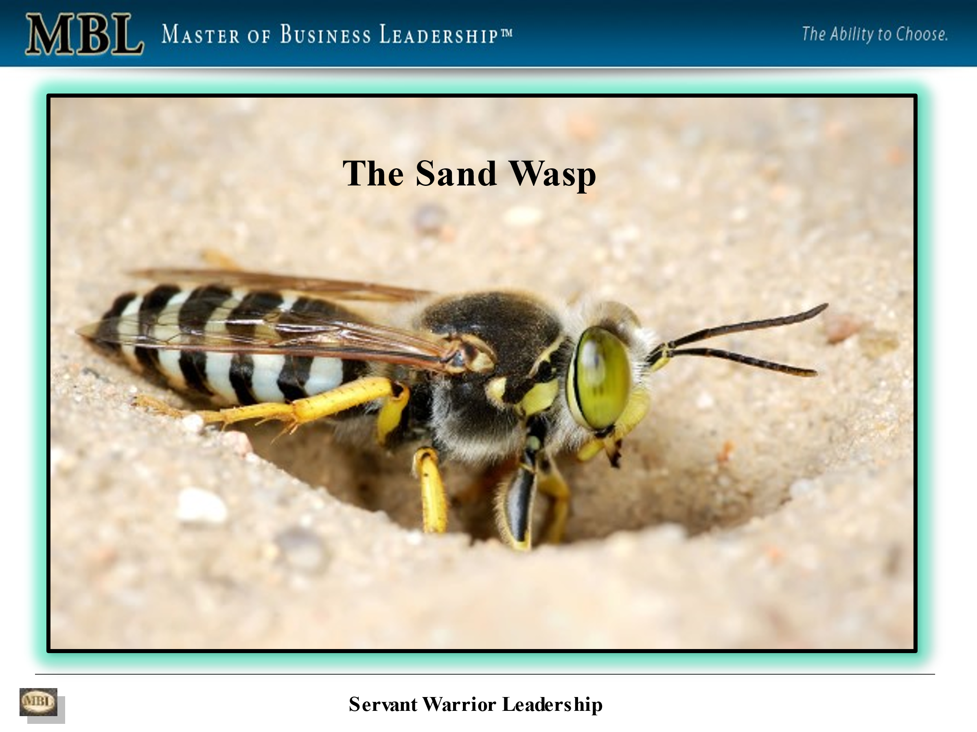
The sand wasp lives in the desert floor and it builds a burrow hole and that's where it lives.
So the scientists kind of set up a viewing position, some distance away from the sand wasp lair. And they noticed that every once in a while it would leave and it would go looking for food and it would eventually find some food and come back and put it outside of its hole.
And it would go in and look for predators that might have gone in there while it was away. And if there was nothing in, they would come back out and get the food and bring it back into their home and eat it.
So after a while, when this was occurring, when the sand wasp had come back with some food and put it outside, the scientist would sneak up and steal it away.
And the sand was, would come out and look for its food and the food would be gone and the sand wasp, would be, I guess, upset or whatever sand wasps do, but it would have to go and find some more food and it would go and find food and eventually come back and do the same thing.
Again, it would put the food outside the burrow and go and check for predators and the scientists would steal the food away again. and this happened over and over again until the sand wasp died of starvation.
kathleen: Oh,
phil: see that sand wasp had a habit that was so hard hardwired into it, that it would rather die than change.
Right. Right. And that's like all of us, it takes an incredible amount of effort for what I refer to as emotional labour to move outside of our comfort zone. And develop the new habits that are needed for us to achieve better results than we're currently getting.
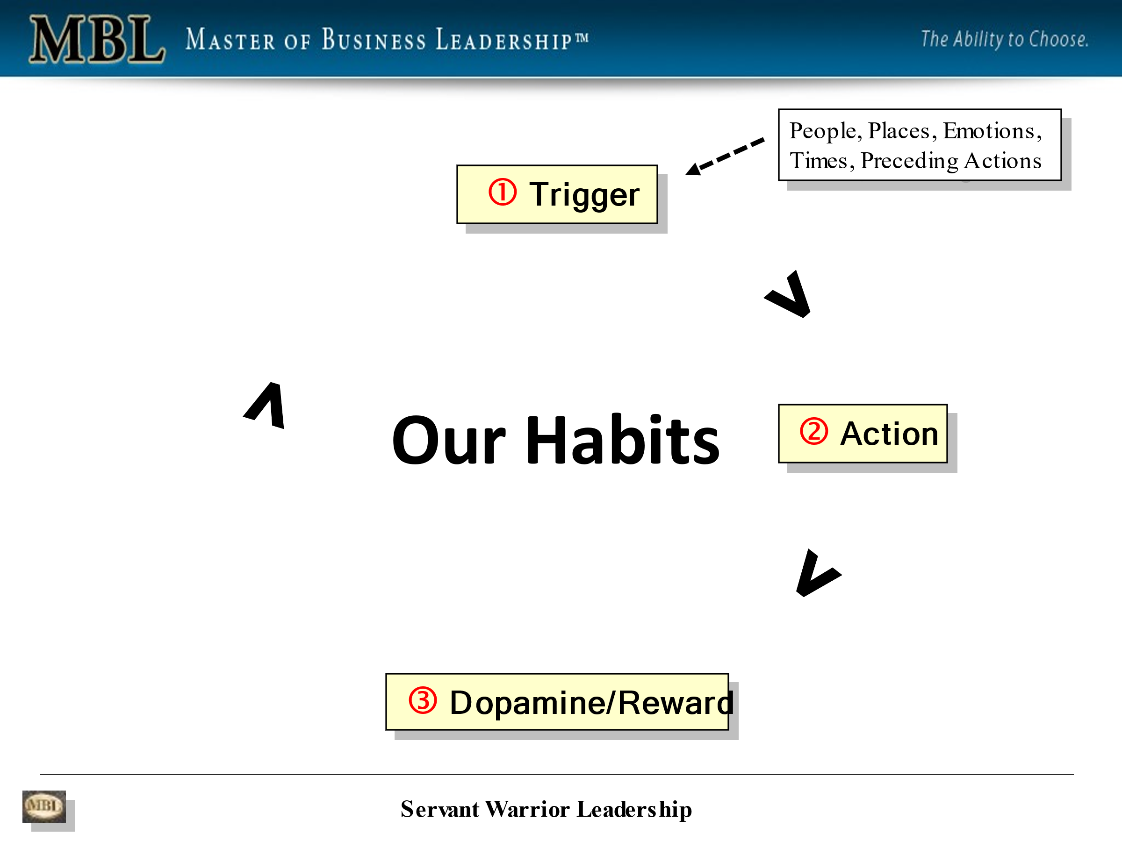

peter: So let's jump in there. When we want to do that, which of those three points on your previous screen do we start with? Do we look for a better trigger? Do we look for the reward?
phil: Great question. You start with a vision of a desired result. Okay. You start with developing, you need to develop a strong, emotional connection to something you want to achieve.
That's going to be greater than the fear that gets triggered in you when you start to move in that direction. Oh, okay. Okay. So that vision, that motivation, that emotion, it's called an emotional anchor. That emotional connection with something you have, you want to achieve becomes your motivation or your fuel for the journey without that emotional connection, that's stronger than your fear.
You will not be willing to do the emotional labour of moving through the fear and anxiety that change in innovation requires. Okay, so you may want better results than you're currently getting, but if you don't have that, that urgent desire for better results, that emotional connection that fuel for the journey, you won't be willing to do the emotional labour that getting better results requires.
peter: Okay. So that makes sense.
Let me ask you something else there. If there's pain involved, does that help reinforce you getting over the fear and adopting that new habit quicker?
phil: Yes.
peter: And let me tell you why I ask you that. Some years ago, I badly injured my left shoulder and I was having physiotherapy. And because I'm right-handed, if I put a jacket on, I would put my right arm into the jacket, first, lean my right arm over my shoulder and then put my left arm in.
But because my left arm was so painful, my shoulder was so painful, that was an extremely painful maneuver. So I said, well, if I put my left arm in first, I've got all the room in the world to get it in without it causing pain. And then I can manipulate my right arm and it worked, it was beautiful. But the next morning I started putting my left arm and it took me over two weeks before it became automatic and a habit.
But once it did stayed with me for as long as it needed to. That's why I asked if there is pain involved, can it be an additional motivator?
phil: Yes. That's a great question, by the way. There's only two sources of motivation that will cause us to want to leave our comfort zone.
One is pain or an urgent desire for better results. Or the other one is passion and hardly anybody's connected with their passion at least initially. So for the most part, the motivation usually comes from pain and an urgent desire to move away from something that's causing you pain or an urgent desire for better results.
I need higher levels of employee and customer engagement, I need to generate more revenue, reduce turnover, reduce burnout, whatever the pain is, that becomes the motivation. If it's great enough for change. Right. And this brings up the second biological source of resistance we have to change.
And that is our existing habits. Once we develop a habit, it's there forever. It's a neural network pathway in our brain that we create through our actions. That's how the brain cells connect. That's what a habit is. And although we can develop new habits at any age, those new habits are going to be weaker than our old habits.
Because there's an insulation layer that goes around the neural network pathway called myelin. And it's thicker when we're younger than when we get older. Oh, okay. So there's going to be an ongoing battle internally. For control for dominance between our new habits and our old habits. Even if the new habits work better, even if the new habits provide better results than our old habits, so that developing and strengthening new habits requires repetition, dedicated, repetition over time.
So that in time they become the default way of being, but it's your old habits are never going to go away. They're always going to be there. And without that dedicated practice, it becomes very easy. It takes less of our metabolic energy to slip back into old habits than to stay with the new habits.
peter: Let's see what else we've got here?
phil: So this is the journey to getting better results. This is about what happens and the emotional labour of moving through the fear and anxiety that gets triggered when we leave our comfort zone. And that's why we need an emotional connection with a desired result that motivates us to do the emotional labour of moving through the discomfort that changing innovation creates in us.
And if we're not willing to do that, if we're not willing to do the emotional labour, if we don't have that, that emotional connection to what it is we're trying to achieve, that's stronger than our fear. Our comfort zone becomes our prison.
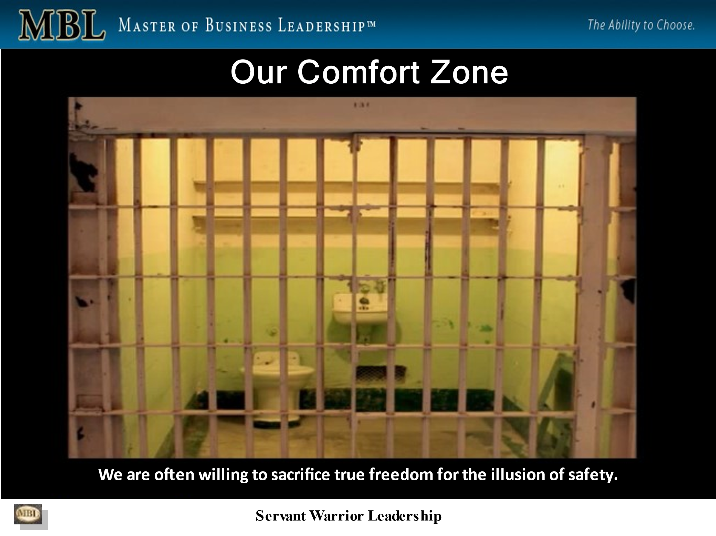
kathleen: And I mean, this is so true, not just in your personal life, but also in business.
phil: I mean, everything. Yeah. We're not. We have one set of habits that we take with us everywhere, business, personal, everything. We're not two different people. We're one person with the same set of habits. The good news is when we develop better habits in one part of our life, we carry it over into all aspects of our life.
Everything gets better. That's why I say the development of our emotional intelligence guarantees not only career, but personal and corporate success. Right? So there's this go ahead, Peter.
peter: No. I was going to say what happens when we've been sitting for a number of years inside that comfortable cell that you had on the previous slide and some huge outside force, some factor comes along and smashes that cell completely and takes away everything that kept us in there.
I guess we are faced with two choices. We can either give up or we can abandon all the old habits and, and immediately start building some new ones.
phil: that's exactly right. Those are the two choices. And the development of our emotional intelligence is critical for us to develop the new habits we need to survive to turn the challenges we face into opportunities for better results.
And without that, without that emotional intelligence, we don't stand a chance. Being willing to do that. So we get deeper and deeper into our comfort zone and our world, our paradigm becomes smaller and smaller and smaller, and our results get worse and worse and worse. Does that answer your question?
peter: Yes, it does. It does because in my experience I've seen people with similar backgrounds, abilities, resources, similar in many ways faced with a serious set of circumstances. And one of those, if I'm looking at two, I can think of many examples will go through a period of discomfort survive and go on to do great things.
The other one will be destroyed and will never recover.
phil: Yep. And unfortunately our lack of emotional intelligence. See our educational system and our employment system has focused primarily on our ability to do intellectual labour, and they've really done nothing, little or nothing to develop our emotional intelligence.
So we have this tsunami of change coming at us that we are completely unprepared for. We, we have to be developing our emotional intelligence to be able to deal with the challenges we're facing and look for the opportunities embedded in those challenges without our emotional intelligence to assist us.
We'll be overwhelmed right.
kathleen: So how do we develop this emotional intelligence?
phil: Oh, you hire me. So here's a picture. This is just, I just wanted to show you a picture of where our amygdala is located. And this is what's referred to as our old lizard brain, that's been around it's at the base of our of our spinal column.
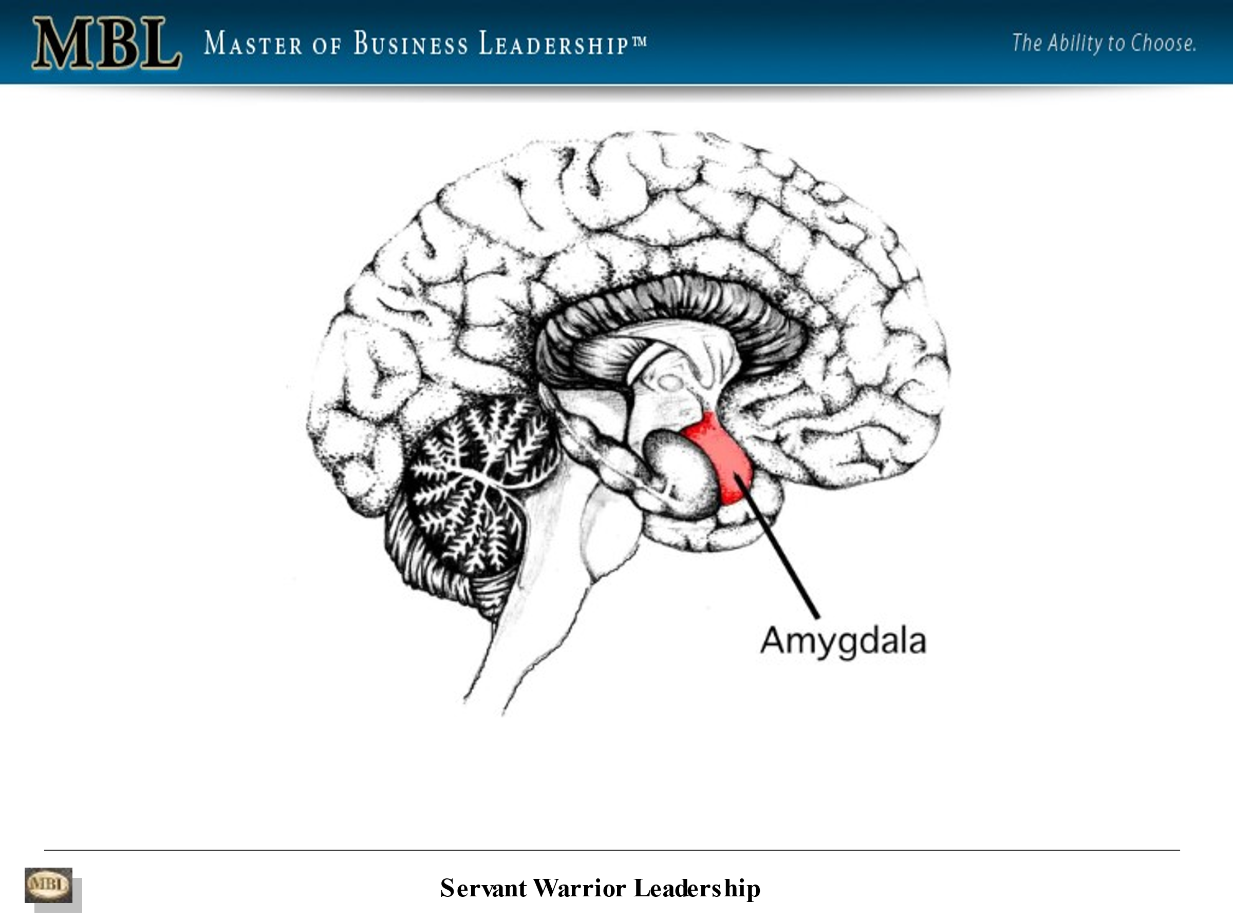
And it's been around for about 500 million years. The middle part of our brain is called the limbic system or our emotional brain. And the outer part is the neocortex, which has been around, I think, for about 250 million years. So much of what drives us comes from this part of our brain.
Right. And. When we resist change, it causes our walls to go up. We become more resistive, more judgemental, more attached to an outcome when we're being controlled by our ego-based fears. It really blinds us to the reality of the present moment. It blinds us to our ability to turn the challenges we're facing into opportunities.
And there's another way to look at the difference between intellectual and emotional intelligence. Think of intellectual intelligence as the one tenth of the iceberg, sticking above the water and emotional intelligence is the nine tenths under the water, right? So developing our emotional intelligence will have a massive and incredible multiplier effect on your results.
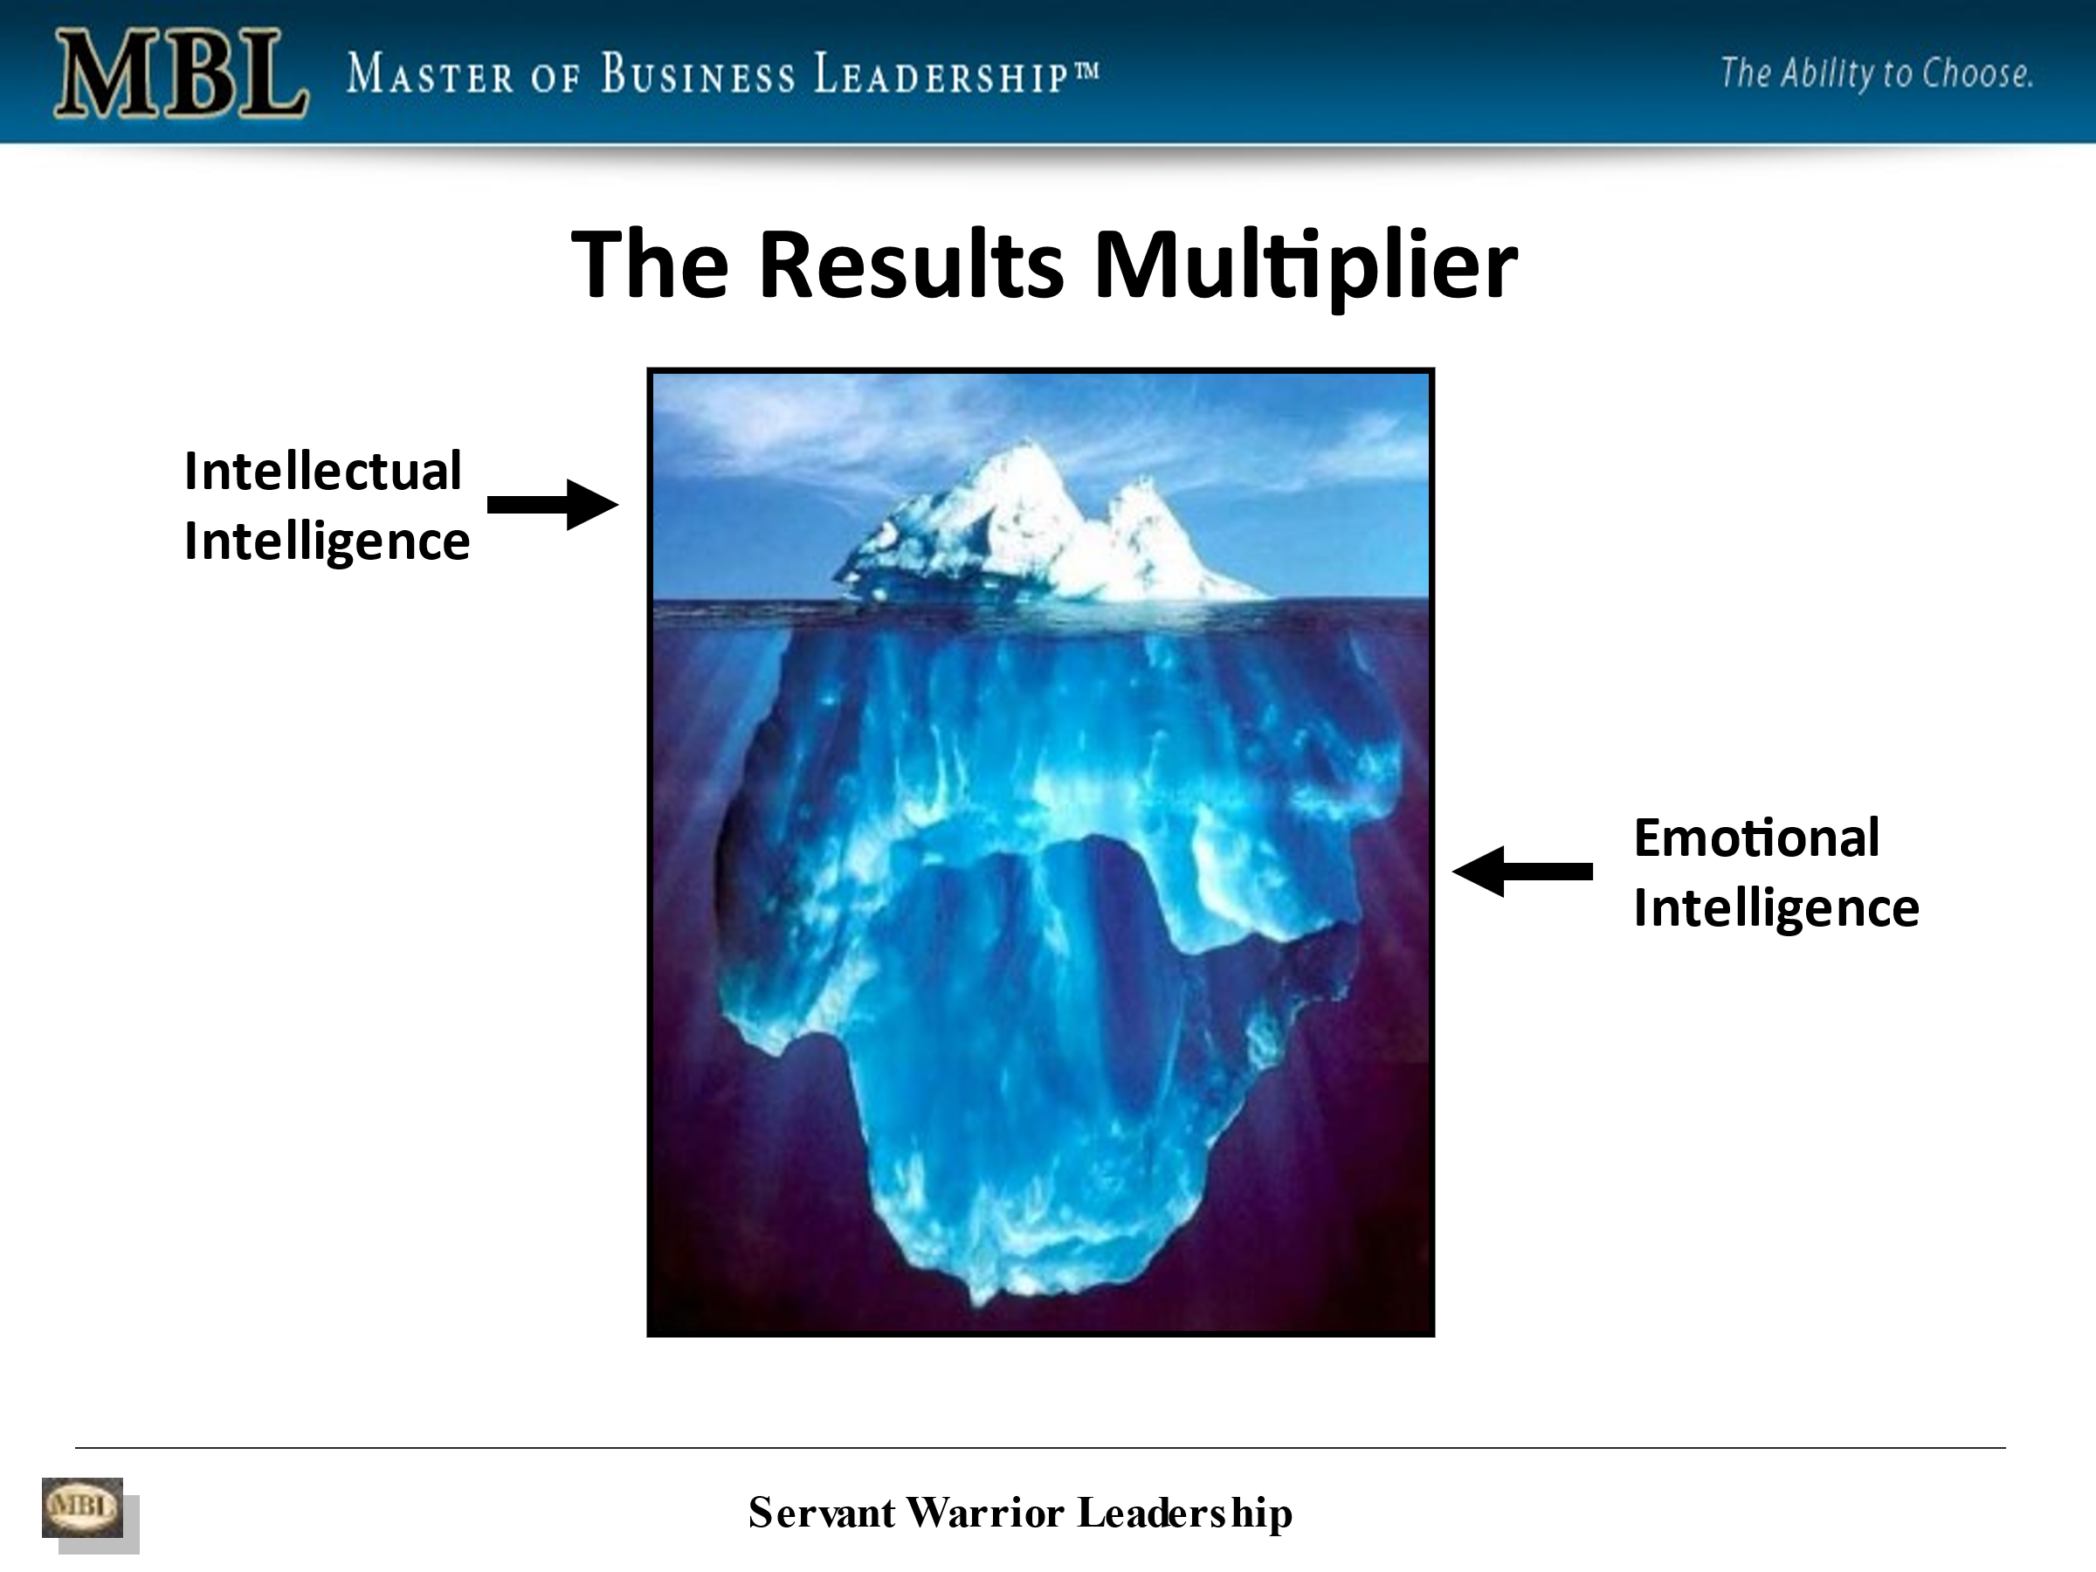
So emotional intelligence is meant to work with our intellectual intelligence to multiply results. Here's another way to think of this. Imagine our ability to do intellectual labour, or our intellectual intelligence as somebody giving us $10,000 a day for 31 days. So at the end of 31 days, you've got $310,000, right. And that's, that's fixed. Now think of emotional intelligence as a penny that doubles in value every day for 31 days.
So day one, you've got a penny day two, you've got two pennies day three, you've got four pennies, day 31. You've got $10.7 million day 40. You've got over $5 billion. Wow. Day 50, you've got over $5 trillion. So the ROI, the multiplier effect of developing our emotional intelligence far surpasses the UC Berkeley study found over 40 years.
Our emotional intelligence, the development of our emotional intelligence far surpasses our intellectual intelligence. And it's something that everybody can do. And it's something that everybody needs to be doing.
This is a slide just saying that each of our emotions has an energy frequency associated with it. And when our walls are up, when we're being resistive, when we're giving into our fear and being resistive, judgmental, and attached to the outcome, the feelings, the emotions we feel often are in this, in this area here.
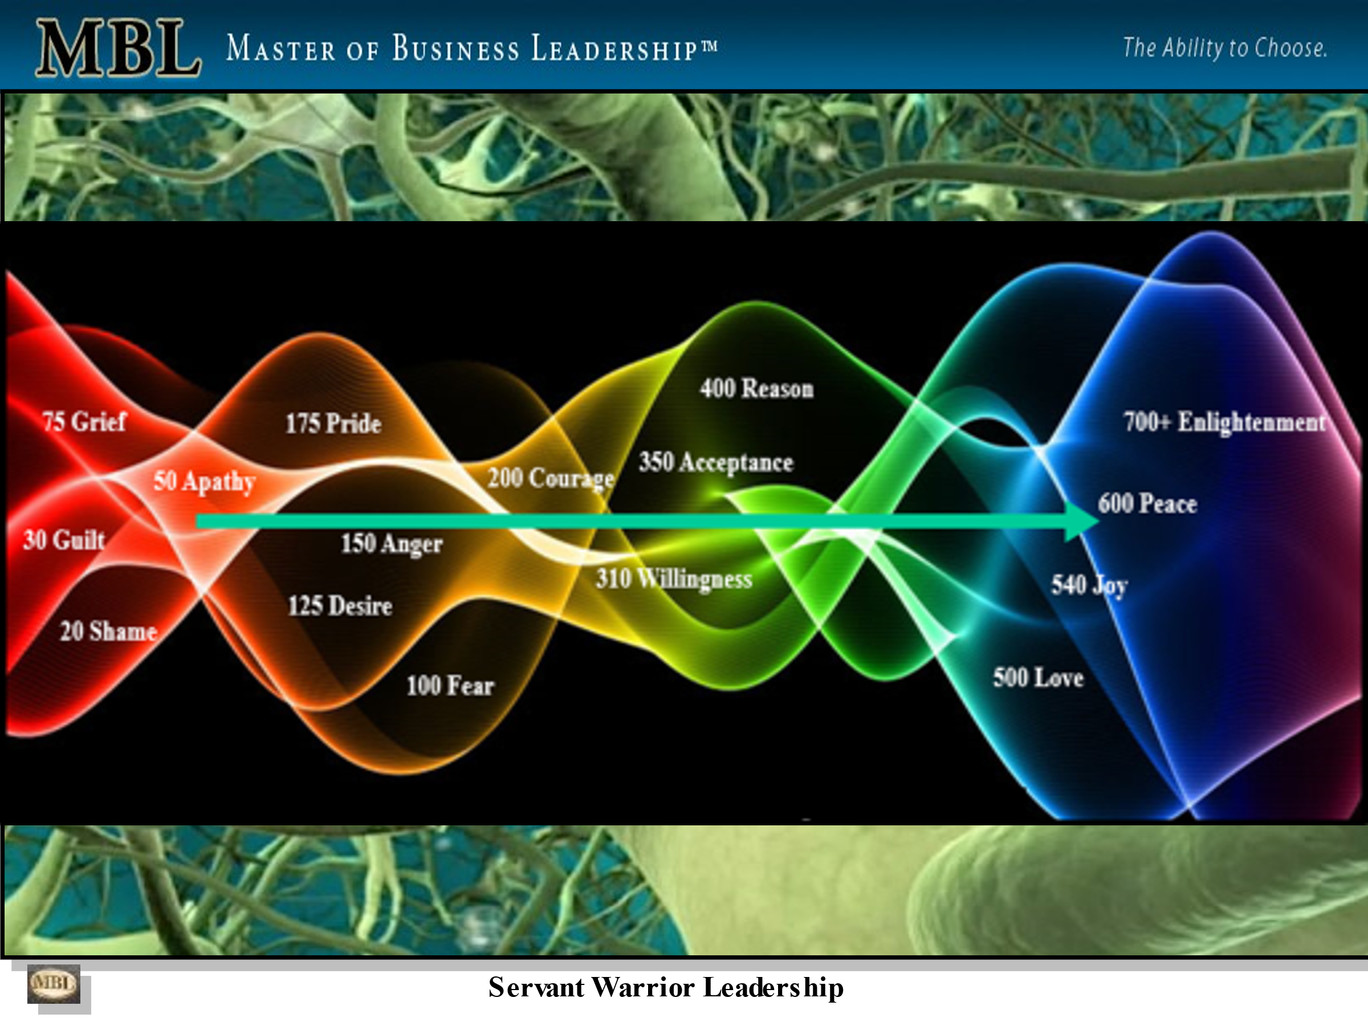
But as we learn to lower our walls, as we learn to stop becoming less resistive, less judgemental, less attached to an outcome, we start experiencing these kinds of emotions. Does that make sense? Yes, you, yes, it does.
peter: Most people feel that anger is always a negative destructive emotion. I would argue that at times, anger could keep us alive and could be in fact, a motivator.
phil: Yeah. Anger is fear. When you see somebody angry, when you get angry, think fear, the anger is simply fear. It's ego-based fear and yes, it can cause us to move outside of our comfort zone to get away from the tiger.
That's trying to eat us, but it also blinds us to the reality of the present moment. It blinds us. Being creative. It blinds us to releasing our genius to connect it, to get better results. So it's anger is a very primal emotion, right.
kathleen: So in a business application, you could almost say that if, if, if a business is afraid to take a risk that has the potential to, to great rewards, but the fear is there and it stops 'em from taking that business risk. They're paralyzed. They can't go any further.
phil: Just there's anger. Yeah. That gentleman in this picture is angry because he's afraid of something.
It creates toxic environments. I don't know if I have the numbers here. Let me just see. No, I don't. The current level of employee engagement worldwide, according to Gallup is about 13%. 13%. Low levels of employee engagement are costing the US economy alone over $1 trillion a year.
And the level of employee engagement has dropped over 25% in the last 15 to 20 years. So work environments are becoming more toxic. Employees are feeling less safe with the accelerating rate of global change. And if you don't feel safe, You're less willing to take risks. And if you're not willing to take risks, if you're not willing to fail, then change in innovation is impossible, right?
Embracing change is impossible. Being able to turn challenges into opportunities for better results is impossible. And there's almost a one-to-one correlation. Again, according to Gallup, between the level of employee engagement and the level of customer engagement. So if your employees don't feel safe, if they don't feel engaged in what they're doing, then neither do your customers.
Right So good point. The lack of emotional intelligence creates amongst other things, toxic work environments driven by fear.
Has that incredible cost associated with it in dollars and cents? That makes sense. Think if you had 10,000 employees, just as an example, and the loaded labour rate for employee, when you take into account salaries and benefits and everything else, that's a hundred thousand dollars a year. That company's spending a billion dollars a year on, on compensation.
And if their level of employee engagement is 13%, they are wasting 870 million a year. So they've got to spend a billion dollars for 130 million worth of effort.
So the fear gets triggered in us due to a lack of emotional intelligence, due to a lack of consciousness, due to a lack of awareness is hugely costly. Not only in corporations, but in our careers and in our personal life, because we take those same habits home with us. Have you ever heard the saying, people are hired for the IQ and experience and they're fired for a lack of emotional intelligence?
Nobody can work with them, right? There are whole industries where employees are burning out as we speak today. Where turnover is incredible. Yes. The medical industry is one of them, right? And largely because of a lack of emotional intelligence. See a lot of these higher tech industries, the folks in them have high IQs and low EQs because when they get scared, they run to their strength and away from their weakness. And if they have a high, an above average level of ability to get results through intellect, that's how they try to handle every problem. It's kind of like the old saying, if all you've, got is a hammer, everything looks like a nail.
peter: Like a nail that's right. So, so here that raises a huge question.
Why do we have so little effort in universities to improve people's emotional intelligence? Why is it only exceptional people like you who are teaching this? Because we just don't hear of other organizations doing it.
kathleen: Not even in university Peter, I would say in grade school, this should be taught at a very age.
phil: I mean, do you do you want my conspiracy theory?
peter: Go ahead. Yes, we are great conspiracy theorists.
kathleen: More like truth seekers.
phil: because we were never taught to develop our emotional intelligence because it made it easier for us to be controlled by our fear.
If we had developed our emotional intelligence, if we had been taught to develop our emotional intelligence from birth, we would be a lot harder to control I fear. Absolutely. And it would change the face of the planet. Yeah, it would change the type of government. It would change employment. It would change everything. The development of our emotional intelligence creates freedom from fear. It creates freedom from ego-based fear.
We get bombarded with fear messaging constantly 24 7. Yes. And without the development of our emotional intelligence, to be able to move through that fear that it triggers in us. We become enslaved by our fear.
peter: Good point.
kathleen: Yes, absolutely, I believe that
phil: let's see what else? So here's one slide about ego. Our ego wants us to feel superior to, or inferior to others, but it never wants us to be equal, feel equal. Our ego never wants us to be in the present moment. Our ego wants us to be focused on some potentially better future moment or some past moment, but it never wants us to be in the present moment.
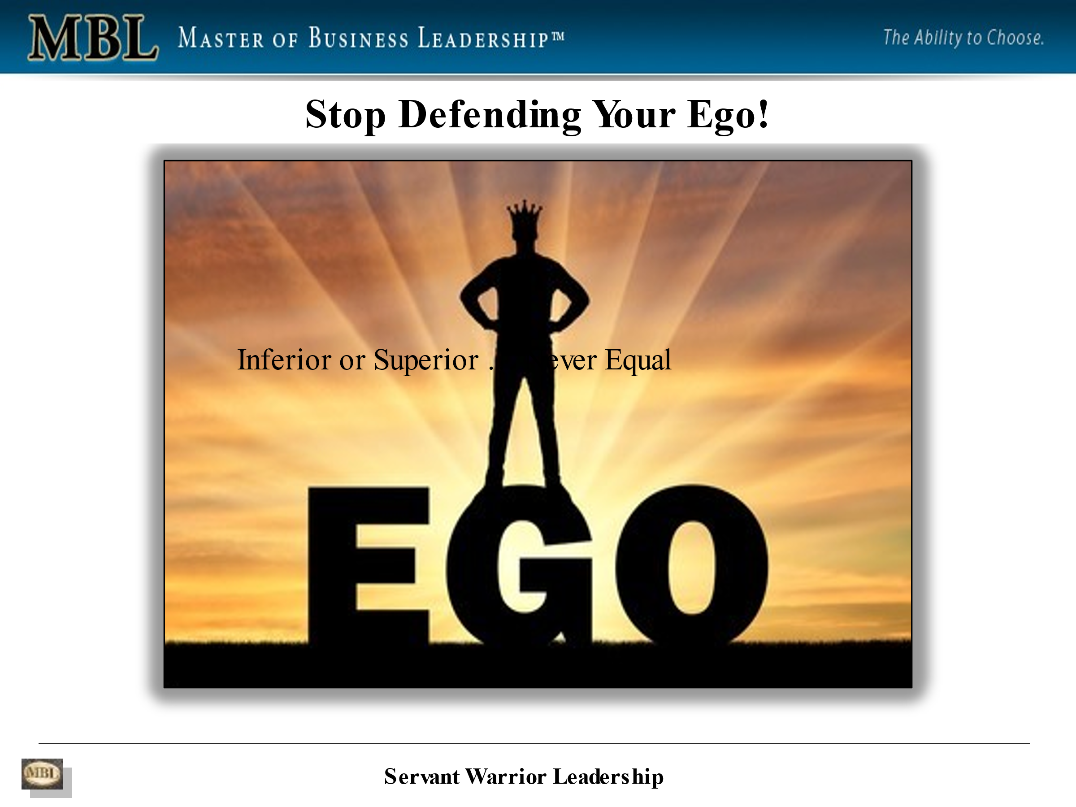
And the present moment is all that exists. The present moment is all that will ever exist. And by learning to lower our walls, we become more present in each moment. And the person most present is most influential. Right? So again, developing our emotional intelligence allows us to be more present in each moment, which enables us to obtain better results, become more inspirational leaders.
kathleen: And you almost have to look, you know, children are so good at living in the moment aren't they? And it has been taught out of us just from, from our parents. And I don't mean to offend any parents out there, but, you know, that's where it starts. And then we get trained out of that.
But if you observe a child, just even at play, they're all in that in the moment.
phil: And that's why, when you think of it, that's a great point, Kathleen, when you think of it, when we were younger, A day seemed like a week and a week seemed like a month and a month seemed like a year. Yes it's because we were living more in the moment.
Right. But as we became more socialized, we unconsciously started giving away our energy. We became more resistant, more judgemental, more attached to the outcome. We became more connected with our egos and that stopped us from living in the present moment. And so time sped up. We were trying to get out of the present moment to get to some better moment that was going to offer a better result in the present moment.
And we, it just it's we've been on this negative spiral. That's why, when you think of kids, when you're younger, they've got to smile from ear to ear. As they get a little older, seven, eight years old, that smile becomes a little less and they become a little more analytical, a little more rationalizing.
And by the time they're teenagers that smile's gone away, that smile's still there. It's buried beneath their walls of resistance, judgment, and attachment to outcome. And going through the MBL program enables you to lower your walls. That smile comes back. So you get back to the openness you had as a child, but this time with the wisdom of a master, see children have openness, but they lack wisdom.
But by going through this program, you reconnect with both. First, you reconnect with the openness you had as a child that allows you to be in the present moment. But this time with the wisdom of knowing what's going on in you and around you, so that you're not enslaved by the bombardment of fear that you get every day, You're able to feel the fear and move through it so that it doesn't control you.
peter: Listening to you talking about children, here's a question for you. I've lived in Africa for a lot of my life, and I had spent quite a lot of time with people who we would consider very unsophisticated, tribal people who had hard and harsh lives, but to my mind, in many ways, were much happier and well in tune with their lives and living in the present much better than us in the Western societies.
So would I be correct in saying that their level of emotional intelligence for their situation was probably a lot better than ours and enabled them to survive the harsh times much easier than we could. .
phil: So the answer is yes. Right. There's only one way to develop emotional intelligence and that's by doing the emotional labour of moving outside of your comfort zone and through the fear that that triggers in you towards the vision of your desired results, developing those habits, an awareness along the way that creates remarkable results.
So it's the only way. I had the good fortune of being born with dyslexia. And that caused me to have to do a lot of what I refer to as emotional labour, because my brain doesn't work the way most people's brains work, but I can tell you that there is no way that I would be doing what I'm doing today. If I hadn't been born with dyslexia.
Because it forced me out of my comfort zone, it tore me out of my comfort zone. And it forced me to do a lot of emotional labour that gave me insights into myself and other people that I share in the MBL program. So there is no other way. We have to be willing to move through our fear towards what it is we're trying to achieve in order to develop our emotional intelligence.
In order to release the stranglehold that our fear has on us. There is no other way. So the good news is I'd say with tongue in cheek that we have this tsunami of change coming at us. That's going to rip us out of our comfort zones, whether we like it or not, we can't hide from it. And for some people it's going to motivate them to grow, to develop their emotional intelligence, to embrace change. For many other people, it's going to drive them further into their comfort zone and they're going to become more resistant, more judgemental, more attached to the outcome.
And we're seeing that in several parts of the world right now, that's a lot of the underlying tension in the United States. It's a lack of emotional intelligence people being driven by ego-based fear, creating the drama, chaos, and conflict. The cost is unmeasurable. But it's fear.
It's ego-based fear coming from a lack of emotional intelligence.
So we're kind of at a tipping point as a species on the planet, in order for us to be able to move through the accelerating rate of global change. We have to be working on the development of our emotional intelligence. The development of our emotional intelligence is a solution to the challenges we face.
It is the only solution to the challenges we face and the longer we wait to develop it simply the more pain we're going to be in. So that's why I encourage, and I've been encouraging individuals and organizations all over the world for the last 21 years to bet on themselves, by developing their emotional intelligence.
kathleen: Now we know what that means and it makes sense. Absolutely.
phil: Yeah. Well, this is a picture that kind of refers to the. The methodology required in organizational change.
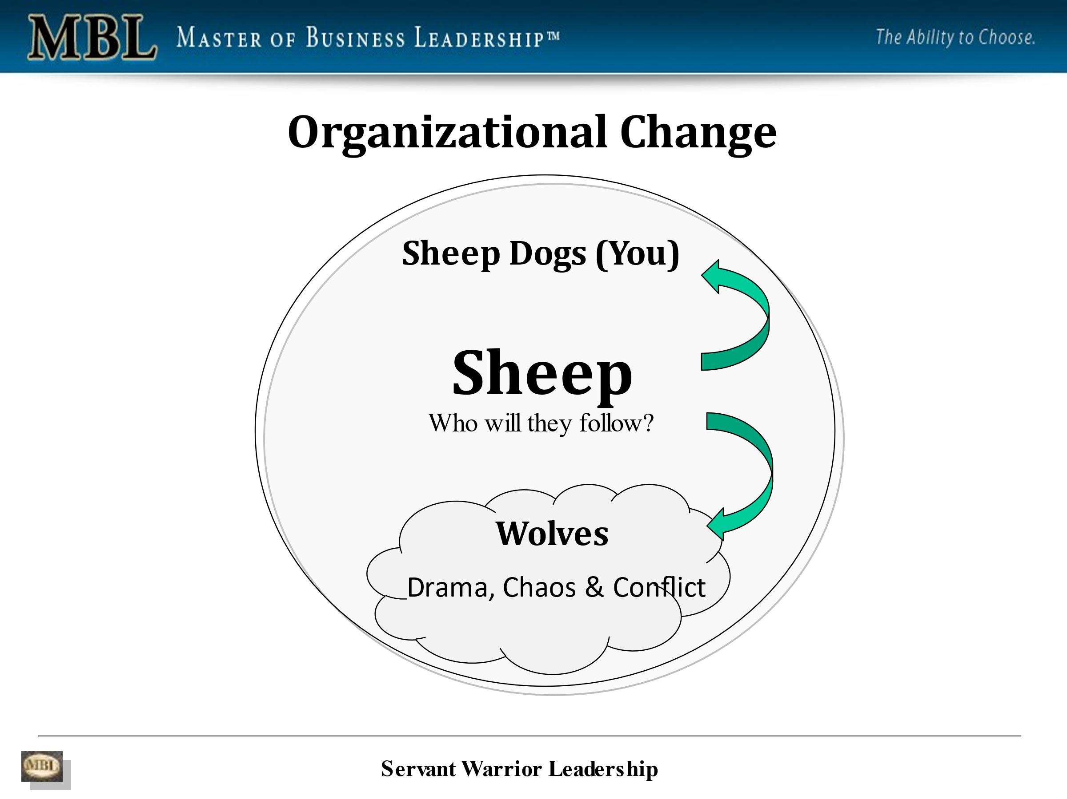
I won't, I won't get too much into it, but the sheepdogs or the people with the emotional intelligence are the ones that are going to battle the wolves that are trying to feed off of the, the sheep in the organization that are the ones that are creating the drama, chaos, and conflict within the organization. The sheepdogs are the ones that are going to lead the rest of us to safety.
Right? So that's what the MBL program does. The MBL, the Master of Business Leadership program develops sheep dogs that are able to become inspirational leaders and generate remarkable results. The development of our emotional intelligence. I can't stress this enough. The development of our emotional intelligence will guarantee career personal and corporate success because it's physics.
It has to do with energy physics. So, but it's not easy. It requires emotional labour. Like you, your example, Peter, with the tribal people dealing with harsh conditions. That's the price we have to pay for our freedom from fear. Oh, absolutely. There's no magic here.
There's no silver bullet in order for us to free ourselves. From our fear in order for us to get remarkable results, in order for us to ensure that the rest of our life is the best of our life, we have to be willing to do the emotional labour required in leaving our comfort zone. To get it right?
peter: Phil, you were just talking about your course and what you offered. Do you want to expand a little bit on that? How long is it for instance? Can people do it remotely? Can you tell our audience a bit more?
phil: Yes. I work with people all over the world. Just like this via zoom or Skype. It's a 16 week program where we get together for an hour a week for 16 weeks.
Okay. 16 weeks and there's homework. And so the program's phenomenal. It's interesting. I See, the development of emotional intelligence is an experiential process. It's not an intellectual process. And as folks are going through the program and they're doing the work required they're amazed at the level of awareness and the results they're generating.
And they're really they're saying this is incredible. And I say, yeah, I know, but is there anything I could have said to you in the beginning that could have prepared you for what you know now? And they all say no, there's nothing you could have. There's nothing you could have told me. That could have helped me to understand what I understand now.
And you see that's the difference between knowing something intellectually and knowing something emotionally, right? The development of emotional intelligence is an experiential process that always requires an initial leap of
faith. And that leap of faith is usually driven by fear, by pain, by an urgent desire for better results than they're currently getting, but going through the program, it's interesting going through the program, the motivation changes from a desire to get away from the pain to a desire to move towards the passion.
Right? So as a whole transformation that occurs in the process, it's quite fantastic. It's quite remarkable.
peter: And I have to ask you that while people, students are going through the course, are they picking up things every week that they can immediately apply to improve their level of emotional intelligence and start seeing results?
phil: Yes. They start to see results immediately in the first week and those results keep getting greater and greater and greater and greater. That's the penny doubling journey, right? Absolutely. Excellent. There are, actually you bring up, you remind me there are some companies, some individuals I've been working with for over 13 years because the ROI and learning to master this process keeps getting greater and greater.
And if you could imagine what those conversations are like from week to week, you would be amazed
peter: I can imagine. And I know you have a YouTube channel and we will put the link to that in the description. And I've personally been to your channel and watched the short videos of some of your graduates from your course who have some amazing things to say about the benefits they've received from your course, and also from improving their emotional intelligence.
So I would certainly suggest to our audience who are watching, have a look at the link and go and see Phil's YouTube channel here for yourself.
phil: Yeah. There's so there are currently Master of Business Leadership, alumni living the United States, Canada, UK, Europe, Japan, Germany, Bosnia, Africa, Australia, the middle east and Saudi Arabia and career revenue generated so far as over a billion and a half dollars.
So this stuff everything I've been telling you works. It produces incredible results. You know, I've gone from from pulling copper wire outta the back of factory dumpsters when I was nine years old and selling it for 5 cents a pound to helping individuals and organizations generate hundreds of millions of dollars.
peter: Right, right. That's saying something.
kathleen: And, you know, I would say that this, although it's called the Master of Business Leadership, this, this can be for absolutely everyone because it pertains to your personal life. It it, it, it goes throughout everything business and personal, I think.
phil: Yep. As I was saying earlier that we're the same person, no matter where we are.
Absolutely. We bring the same habits with us. Whether it's home or work or wherever. Sometimes we think we're different people, but we're not, we put on masks, but we're the same person beneath those masks. Absolutely. So I was also thinking that as kind of a little bonus here for anybody that's interested they can reach out to me on my on my zoom calendar and I'd be happy to meet with them and hopefully Provide some value in helping to develop their emotional intelligence.
kathleen: Wow. That is so very generous. And we're going to put that link aren't we, Peter.
peter: Absolutely. That'll be in the description and, and a subtitle for the video and for our audio listeners check in the description and you can find that link for Phil's free consultation. Thank
you, Phil.
That's great.
kathleen: Yes, that is
phil: so my final, my final little comment here is I would encourage everybody listening to this to bet on themselves by developing their emotional intelligence. They won't regret it.
peter: Certainly from what I've heard and seen of your literature, your material, and what you said today, I would endorse that. And before you go, let's put our audience out of their misery. And why don't you tell them about the company you mentioned right up the beginning? Your trillion-dollar company.
phil: Thanks for reminding me, that company is Apple. Ah, right. That's why, when you go in an Apple store, the energy you feel is an example of a more emotionally intelligent environment. And it's a very different energy from the energy of the source surrounding it. See, they're not trying to sell you anything.
They want you to have a great experience. They want to understand your pain and if possible, offer a solution. But. Whether or not you buy anything is secondary to their desire to want to serve you. And maybe you'll go tell your friends and they'll tell their friends. And that level of trustability is a direct reflection of the level of emotional intelligence within the individuals in that organization.
And their level of emotional intelligence inspires the people, the clients, the customers that come into the store to lower their walls. It's called actually, emotional contagion So people are drawn into that environment because of the level of emotional intelligence. They feel safer in that environment.
More and more companies are hiring and developing and promoting emotional intelligence. It represents emotional intelligence represents the future of organizational development. Right.
peter: I agree with you a hundred percent. Yes. Well, thank you, Phil.
That wow. We could go on all day. This is so fascinating. Everything you, you have been telling us in our audience it's really great stuff. And, and I think you're right. The future of the planet rests on people, listening to people like yourself and learning how to improve their emotional intelligence, because otherwise the future doesn't look too good. Quite honestly
kathleen: agree.
phil: Well, we're at a tipping point and this is the opportunity where we're best able to rise up.
kathleen: Absolutely. Well, thank you so much, Phil. For that. It, it was just so enlightening and, and we hope to see you again. And of course we welcome your suggestions for the type of expert guests you'd like to see and hear on the show, and please feel free to reach out to either Peter or myself.
We would love to hear from you. So until next time everyone take care. Bye bye.

